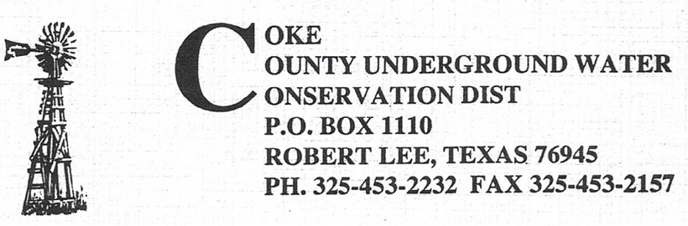

The Coke County Underground Water Conservation District will hold a Regular Business Meeting of the Board of Directors on Tuesday, November 12, 2024 at 6:00 pm in the district office in the Coke County Courthouse 13th East 7th Street, Robert Lee, Texas.

Agenda:

1. Call Meeting to Order

2. Public Comments

3. Approve Minutes September 10, 2024 Regular Meeting

4. Public Hearing for Proposed Changes to Rules and Regulations

5. Public Hearing for Proposed Changes to 2024-2029 Management Plan

6. Review Bills and Payments

7. Discussion and Actions regarding TML Insurance Coverage and Costs

8. Discussions and Actions regarding Legislative Consultant for 2025 Calendar Year

9. Review Financial Statements for September and October 2024.

10. Manager’s Reports

11. Other Business

12. Set Next Board Meeting

16. Adjournment